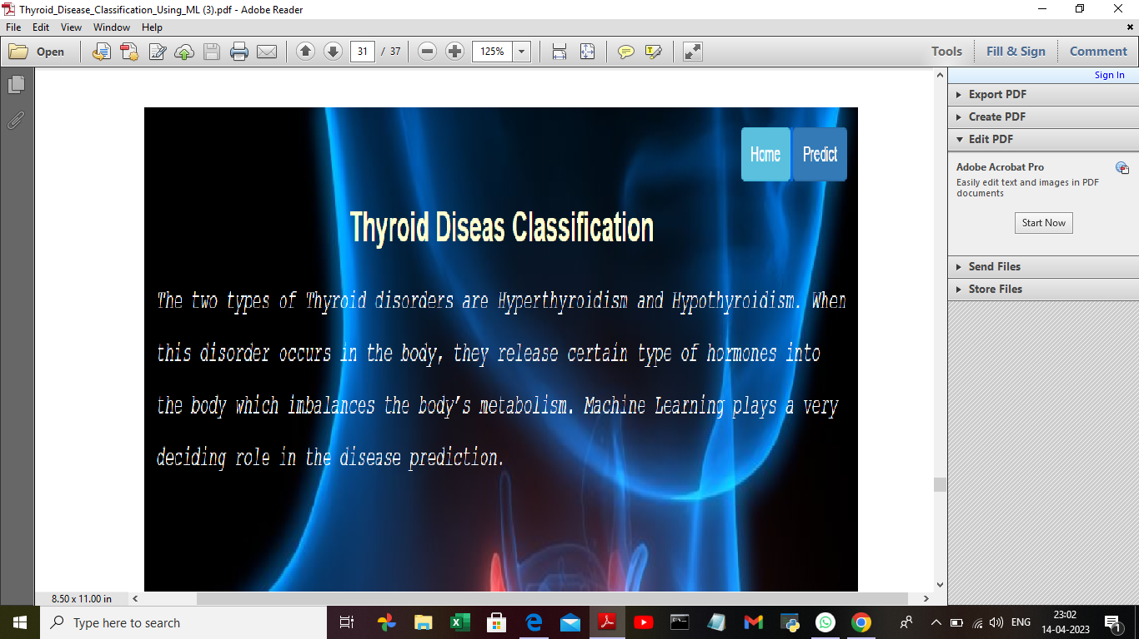

|  |
| --- |
| THYROID DISEASE CLASSIFICATION USING ML |
| PROJECT FLOW   * The user interacts with the UI to enter the input * Entered input is analysed by the model which is integrated   DEFINE PROBLEM/PROBLEM UNDERSTANDING  DATA COLLECTION&PREPATION  EXPLORATORY DATA ANALYSIS  MODEL BULIDING  PERFOMANCE TESTIG& HYPERPARAMETER TUNNING  MODEL DEVELOPMENT  PROJECT DEMONSTRATION”&DOCUMENTATION  PROJECT STRUCUTRE |

THANK YOU

BY- SONA.J

SUSIPRIYA.V

THANISHA.M

SUDHADEVI.G